¹Meshaal Mouawad
Mississippi State University, Electrical and Computer Engineering Department,
This is a summary report of my research assignments I was given by my advisor during my PhD program
Weekly Summary Milestone week 2
Voronoi Diagram Project March 28th 2021
Summary:
In this week I completed studying the code and study the parameters for the robot such as the radius, safety distance …etc I have included what I have studied to keep them as note to review in the future.

Robotic parameters and Specifications

MATLAB Code Studying

The Code Procedure.
1) the code gets an input image and converts it into a graph. 2) the nodes in the GVD graph are Meetpoints and Endpoints. 3) the output is two graphs: a) Pixel Path Graph, b) Quadratic Curves Graph.
B. Parameters
Inputs
InputImage = the map 'Map8_2.jpg'

Radius: it is radius of the robot, this parameter is used to compute configuration. Free space, in case if the graph is disconnected it means robot's radius is big and it can not pass through a narrow corridor or door in the map.
Resolution: this parameter is used to convert image space into real

Outputs
Graph: contains nodes and path between nodes (in pixel)
- path : n*2 matrix for x and y
- from : the corresponding start node
- to : the corresponding end node

Quadgraph: contains the graph in the form of quadratic function for each edge.
- number_nodes: number of nodes in the constructed graph
- node_list: location of the nodes
- edge_matrix: Adjacency matrix of the graph
- path_matrix: The Path between all the nodes
- w_s : size of the work space
- Pol_coefs: coefficent of the quadratic form of the edges

The function SHOWGRAPH shows how you can access tot the structures (GRAPH, QUADGRAPH).

SE = strel('disk',R,N) creates a flat disk-shaped structuring element with the specified radius, R. R must be a nonnegative integer. N must be 0, 4, 6, or 8. When N is greater than 0, the disk-shaped structuring element is approximated by a sequence of N (or sometimes N+2) periodic-line structuring elements. When N is 0, no approximation is used, and the structuring element members comprise all pixels whose centers are no greater than R away from the origin. N can be omitted, in which case its default value is 4.
Note: Morphological operations using disk approximations (N>0) run much faster than when N=0. Also, the structuring elements resulting from choosing N>0 are suitable for computing granulometries, which is not the case for N=0. Sometimes it is necessary for strel to use two extra line structuring elements in the approximation, in which case the number of decomposed structuring elements used is N+2.

Robot Dimensions
To calculate steering directions, you must specify information about the robot size and its driving capabilities. The VFH algorithm requires only four input parameters for the robot. These parameters are properties of the controllerVFH object: RobotRadius, SafetyDistance, MinTurningRadius, and DistanceLimits.
RobotRadius specifies the radius of the smallest circle that can encircle all parts of the robot. This radius ensures that the robot avoids obstacles based on its size.
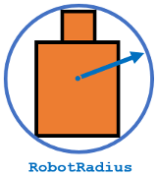
SafetyDistance optionally specifies an added distance on top of the RobotRadius. You can use this property to add a factor of safety when navigating an environment.
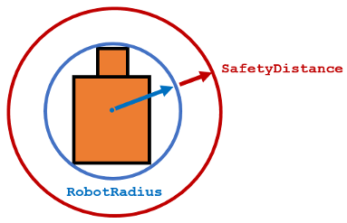
MinTurningRadius specifies the minimum turning radius for the robot traveling at the desired velocity. The robot may not be able to make sharp turns at high velocities. This property factors in navigating around obstacles and gives it enough space to maneuver.
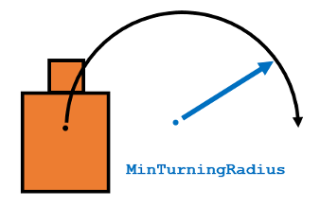
DistanceLimits specifies the distance range that you want to consider for obstacle avoidance. You specify the limits in a two-element vector, [lower upper]. The lower limit is used to ignore sensor readings that intersect with parts on the robot, sensor inaccuracies at short distances, or sensor noise. The upper limit is the effective range of the sensor or is based on your application. You might not want to consider all obstacles in the full sensor range.

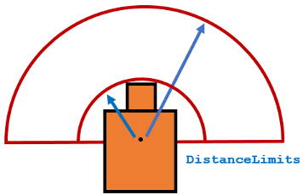

Delaunay triangulation
Triangulation of a planar set of points connects them by edges in such a way that no edges intersect each other (planarity of connection graph) and no more edges can be added without breaking this condition (maximal property).

Delaunay triangulation offers some additional benefits: it maximizes minimal angle of all the triangles in the triangulation. Thus it tends to produce least amount of "thin" triangles. This property by itself may not seem to be very important but it comes from the fact that Delaunay triangulation is a dual object for Voronoi diagram.
A Voronoi diagram of a discrete set of N points (nodes) on a plane can be defined as subdivision of the plane into N regions (aka Dirichlet domains) by finding the nearest node for each point on a plane. If a point is on equal distance d from two or more nodes N[sub]i1[/sub],...,N[sub]ik[/sub], and no other nodes are closer than d then it belongs to the boundary of the corresponding domains.

Vector Field Histogram
Vector Field Histogram. The vector field histogram (VFH) algorithm computes obstacle-free steering directions for a robot based on range sensor readings. Range sensor readings are used to compute polar density histograms to identify obstacle location and proximity. Based on the specified parameters and thresholds, these histograms are converted to binary histograms to indicate valid steering directions for the robot. The VFH algorithm factors in robot size and turning radius to output a steering direction for the robot to avoid obstacles and follow a target direction.

Next Week Plan

- Doing my final project for my Pattern Recognition class

- Complete part 2, in Deep Learning with MATLAB course at MATLAB Academy
- Reading some papers in navigations

END

This Report was submitted in 2019 for Mississippi State University, Electrical and Computer Engineering Department during Fall 2019 foe the course of Introduction to Radars Engineering instructed by Dr. Ball John ¹Meshaal Mouawad, Mississippi State University, Starkville, MS 39759 USA (e-mail: mm4922@msstate.edu).

